SBA 12

Code:

from selenium import webdriver

from selenium.webdriver.chrome.service import Service

from selenium.webdriver.common.by import By

import time

class Sam:

def __init__(self):

self.s = Service("E:\\Downloads\\chromedriver_win32\\chromedriver.exe")

browser = webdriver.Chrome(service=self.s)

url = 'https://www.urbanladder.com/'

print("Accessing Website of Urbanladder")

browser.get(url)

browser.maximize_window()

print("Maximizing the window of urbanladder")

browser.find_element(By.XPATH, "/html/body/div[1]/header/div[2]/div/nav/div/ul/li[4]/span").click()

time.sleep(1)

print("Clicked Dining module session")

browser.find_element(By.XPATH,

"/html/body/div[1]/header/div[2]/div/nav/div/ul/li[4]/div/div/ul/li[1]/ul/li[1]/a/span").click()

time.sleep(1)

print("Clicked Dining Tables")

browser.get("https://www.urbanladder.com/dining-tables?src=g_topnav_dining_dining-tables-sets_dining-tables")

time.sleep(5)

print("Accessing Dining Tables Sets in urbanladder")

browser.find_element(By.XPATH, "/html/body/div[7]/div/div[1]/div/div[2]/a[1]").click()

time.sleep(5)

print("Checking radiobutton by Excluding Out of Stock")

browser.find_element(By.XPATH,

"/html/body/div[2]/div[2]/div[3]/div[2]/div[1]/div/form/div[2]/div/input").click()

time.sleep(1)

print("Removing Pop-Up")

browser.find_element(By.XPATH,

"/html/body/div[2]/div[2]/div[3]/div[2]/div[1]/div/form/div[1]/div/div/ul/li/div[1]/div").click()

time.sleep(2)

print("Click the price filter button")

browser.find_element(By.XPATH,

"/html/body/div[2]/div[2]/div[3]/div[2]/div[1]/div/form/div[1]/div/div/ul/li/div[2]/div/div/ul/li[2]/div[1]/label/input").click()

time.sleep(2)

print("Price filtering from 4199-49055")

browser.find_element(By.XPATH,

"/html/body/div[2]/div[2]/div[3]/div[2]/div[1]/div/form/div[1]/div/div/ul/li/div[1]/div").click()

time.sleep(2)

print("Price filtering")

browser.find_element(By.XPATH,

"/html/body/div[2]/div[2]/div[3]/div[2]/div[1]/div/form/div[1]/div/div/ul/li/div[2]/div/div/ul/li[2]/div[1]/label/input").click()

time.sleep(2)

browser.get("https://www.urbanladder.com/products/arabia-6-seater-dining-table?sku=FNTBDI11TK10001&src=room")

time.sleep(5)

print("Accessing page of Arabian 6- Seater dining table")

browser.find_element(By.XPATH, "/html/body/div[1]/header/div[1]/div/section[1]/a/figure").click()

time.sleep(3)

print("Back to homepage of urbanladder")

browser.find_element(By.XPATH,

"/html/body/div[1]/header/div[1]/div/section[2]/div/form/div/span/input[2]").send_keys(

"Dining Chair")

time.sleep(2)

print("Searching Dining Chair")

browser.find_element(By.XPATH,

"/html/body/div[1]/header/div[1]/div/section[2]/div/form/div/button/span").click()

time.sleep(2)

browser.get("https://www.urbanladder.com/products/doris-dining-chairs-set-of-2?sku=FNCOMB90BL10895&src=subcat")

time.sleep(5)

print("Accessing webpage of particular product")

browser.find_element(By.XPATH,

"/html/body/div[1]/div[2]/div[3]/div[3]/div[3]/div[1]/div[2]/div[1]/div[10]/form/div/div[2]/div[1]/div[3]/button").click()

print("Clicked Add to cart")

browser.find_element(By.ID, "checkout-link").click()

print("Clicked checkout")

browser.find_element(By.XPATH,

"/html/body/div[1]/div[1]/div[2]/div/div[3]/div[1]/form/div[1]/div[1]/div[1]/fieldset/ul/li[1]/div/div/input").send_keys(

"gourinandana@gmail.com")

print("Passing Email Id")

browser.find_element(By.XPATH,

"/html/body/div[1]/div[1]/div[2]/div/div[3]/div[1]/form/div[1]/div[1]/div[1]/fieldset/ul/li[2]/div/input").send_keys(

"683000")

print("Passing Pincode")

time.sleep(3)

browser.find_element(By.XPATH,

"/html/body/div[1]/div[1]/div[2]/div/div[3]/div[1]/form/div[1]/div[1]/div[1]/fieldset/ul/li[7]/div/textarea").send_keys(

"ABC")

print("Passing Address")

browser.find_element(By.XPATH,

"/html/body/div[1]/div[1]/div[2]/div/div[3]/div[1]/form/div[1]/div[1]/div[1]/fieldset/ul/li[8]/div/input").send_keys(

"Harry")

print("Passing First Name")

browser.find_element(By.XPATH,

"/html/body/div[1]/div[1]/div[2]/div/div[3]/div[1]/form/div[1]/div[1]/div[1]/fieldset/ul/li[9]/div/input").send_keys(

"Ron")

print("Passing Lastname")

browser.find_element(By.XPATH,

"/html/body/div[1]/div[1]/div[2]/div/div[3]/div[1]/form/div[1]/div[1]/div[1]/fieldset/ul/li[10]/div/div/input").send_keys(

"9876543210")

print("Passing Mobno")

browser.find_element(By.XPATH,

"/html/body/div[1]/div[1]/div[2]/div/div[3]/div[1]/form/div[1]/div[1]/div[2]/div[1]/div/input").send_keys(

"xyz")

print("Passing code")

browser.find_element(By.XPATH, "/html/body/div[1]/div[1]/div[2]/div/div[3]/div[1]/form/div[2]/input").click()

browser.close()

ob1 = Sam()

Output:

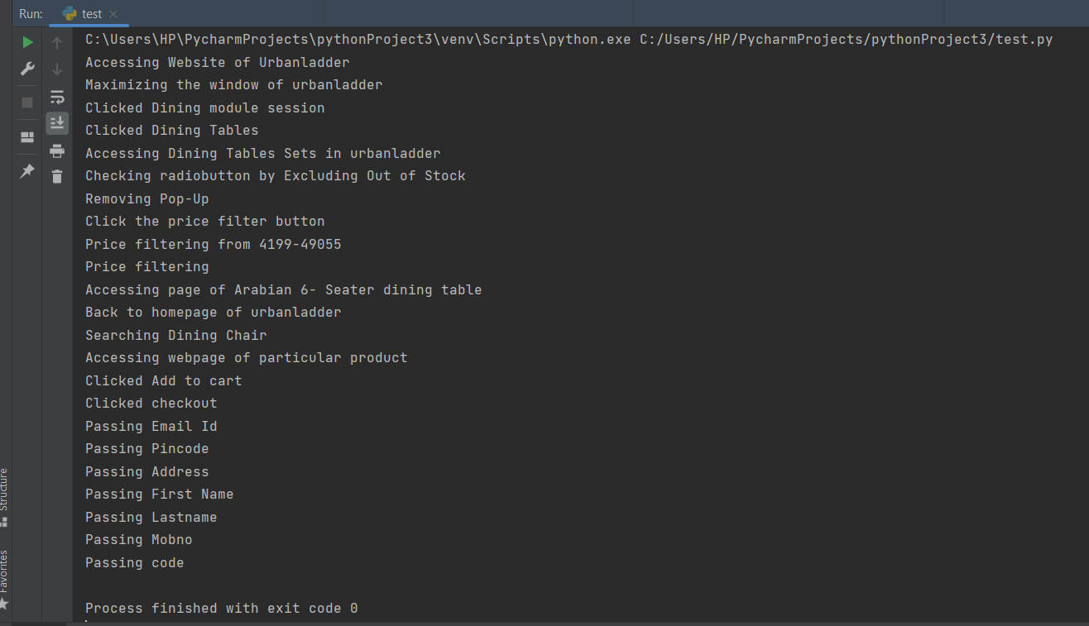

C:\Users\HP\PycharmProjects\pythonProject3\venv\Scripts\python.exe C:/Users/HP/PycharmProjects/pythonProject3/test.py

Accessing Website of Urbanladder

Maximizing the window of urbanladder

Clicked Dining module session

Clicked Dining Tables

Accessing Dining Tables Sets in urbanladder

Checking radiobutton by Excluding Out of Stock

Removing Pop-Up

Click the price filter button

Price filtering from 4199-49055

Price filtering

Accessing page of Arabian 6- Seater dining table

Back to homepage of urbanladder

Searching Dining Chair

Accessing webpage of particular product

Clicked Add to cart

Clicked checkout

Passing Email Id

Passing Pincode

Passing Address

Passing First Name

Passing Lastname

Passing Mobno

Passing code

Process finished with exit code 0